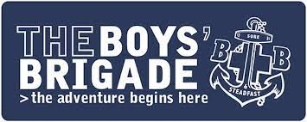
1ST UXBRIDGE BOYS’ BRIGADE
COMPANY REPORT
2021/2022
As the past session draws to a close, we can look back over it and say that, on the whole it has been a good year for us. After all the problems of 2020 & 2021 it was good to finally meet again in a more ‘normal’ setting after all the restrictions and get back to doing a full programme with all our 3 age groups.
Both our Anchors and Juniors, and a few of the older boys started the year off with an activity afternoon at Felden Lodge, BB Headquarters in Hemel Hempstead, where they enjoyed an afternoon of games with other companies in the London District.
Our Anchors have grown from strength to strength over the past year, starting with 6 boys, we managed to double our numbers to 12 by the end of the year. The only downside is that Mr. C, who was running the age group left us in December to work on a Masters degree in Guilford, however, Mrs. Bowman and myself have continued keep Anchors going, and what a lively bunch they are!
Our Juniors continued with their activities through the year which involved many things, including cooking. The pizzas they made were great! We also managed to re-introduce gymnastics into our programme, thanks to James Bowman, who is now qualified to take gym. The boys are a very competitive, and active group, so again, we have had to be on our toes to keep them busy.
Our Company and Senior boys have probably had the busiest year this year. As well as their usual weekly activities, our senior boys started work on their bronze DofE. Led by James Bowmen, they embarked on their expedition in October with an overnight stop under canvas, at Felden Lodge. Unfortunately, due to various circumstances, they did not manage to complete the weekend successfully, so will have to have another go.
Both our Company and Seniors enjoyed a day out on the canal at the end of October. Blessed with a lovey sunny day it was great to see the boys working together to work the locks and to steer the boat. Unfortunately, as you all know, the day was cut a little short by my accident!
In the Company Together this year we have restarted holding our usual Saturday coffee mornings and from the 4 we have had we have managed to raise just under £290. Some of which went to support Saidou, our sponsor boy in the Gambia. Once again, a big thank you to Mrs. Newell, Harry, Luke and Daniel’s nan for supplying us with the delicious cakes to sell. They certainly help to make more money and are very much appreciated.
We held our usual firework party in November and invited the Girls’ Brigade along to join us. We had over 60 people who enjoyed a small, low noise firework display, followed by sparklers and a chance to toast marshmallows for those who wanted to.
We have continued to support Saidou, our sponsored boy in the Gambia and will be sending a parcel to him and his family very soon. Thank you to those of you who have donated items.
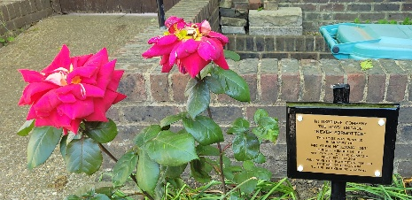
In March last year, we as a company planted a rose, ‘Never Forgotten’ in memory of Mr. Hollaway, just by the rear entrance to the church, opposite our BB garden. This year we placed a permanent plaque by its side as a reminder of the lifetime of dedication Alan, (a founder member) gave to our company as a boy, an officer and company captain for over 30 years. It was also fitting that this was done in our 70th year.
Our Anchors and Juniors ended the year back up at Felden lodge for the big Life 2 The Max event, where they had a day of activities including inflatable slides, climbing wall, bumper cars, laser quest and more.
A big thank you to Carolyn Eyles and her mum for helping out doing a great job looking after the Anchors group.
It was great to finish our year with our display last week. After nothing for 2 years it was amazing to see so many youngsters take part, and a full hall to watch. Thank you to everyone who came along. As those of you that were there will know, we also presented 2 Gold DofE awards. 1 to Anthony Criscuolo and the other to James Bowman. It was especially good to see James get the award as he has been a member of the company from Anchors and has now taken over running our DofE groups. A great achievement in our 70th year.
My thanks to everyone who has been involved with us over the past year. Thank you to our officers, Graeme Moran, James Bowman and Anthony Criscuolo, and our helpers Noellia Bowman and Graham Hinton. My thanks to them especially for keeping things going in my absence with my broken ankle.
Finally, and most importantly, a big thank you to all our parents for your support throughout the year, for bringing the boys along each week and making sure they are well turned out, and for getting them to the few activities we have had. As I always say, I consider our company very lucky that we have parents who support us in the way you do. It is very much appreciated.
Thank you too, to all the staff and members of Christ Church for their support and prayers throughout the year.
We will once again be finishing the year with our BB/GB family barbeque, and we hope to see everyone there.
As this year comes to an end, we look forward to the 2022/23 session and all it brings. We pray that the following year will be a good one as we continue to Advance Christ’s Kingdom among Boys.

Don’t forget, you can keep up to date with all our news on our facebook page @1stUxbridgebb and find out all about us on our website www.1stuxbridgeboysbrigade.org.uk

Our new session starts on
FRIDAY 9th SEPTEMBER 2022
See you then.
Have a good summer everyone
and thank you for your continued support.

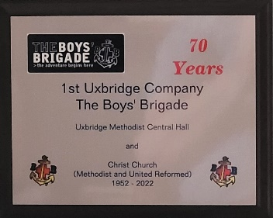
Paul
(Company Captain)

